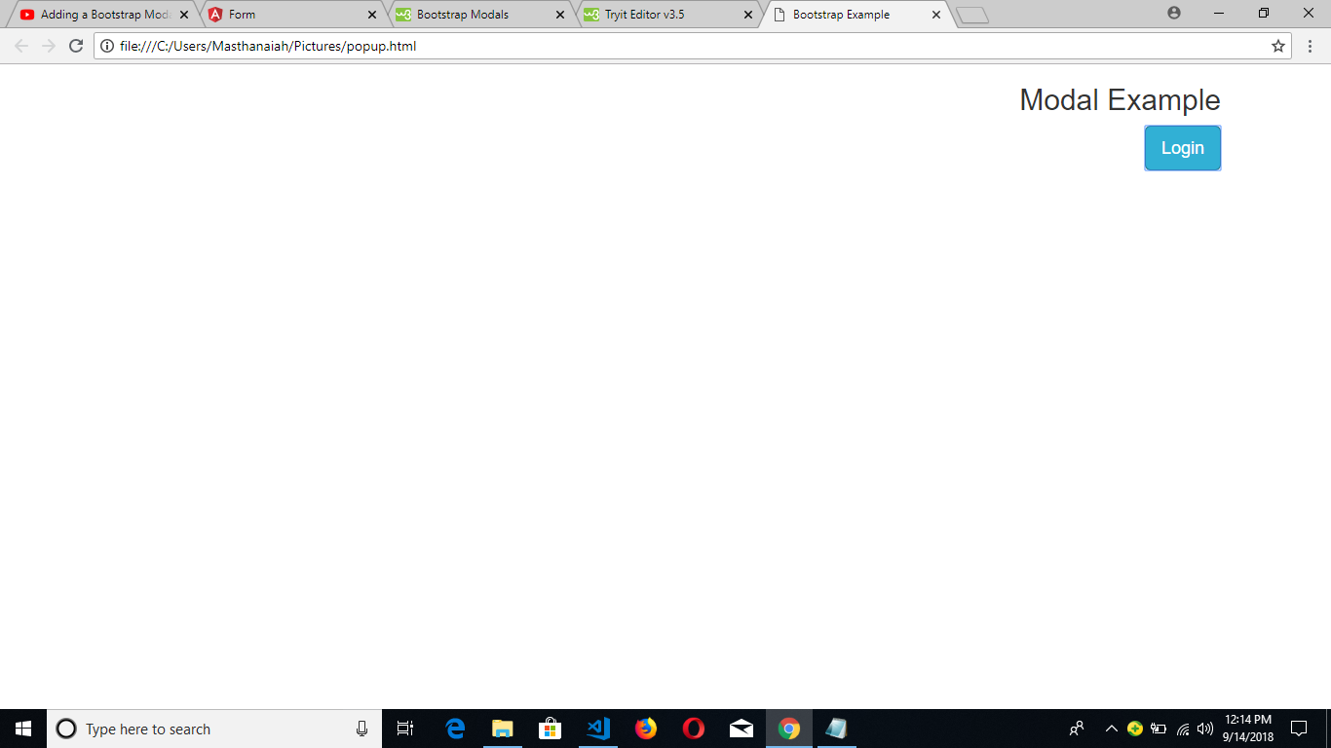

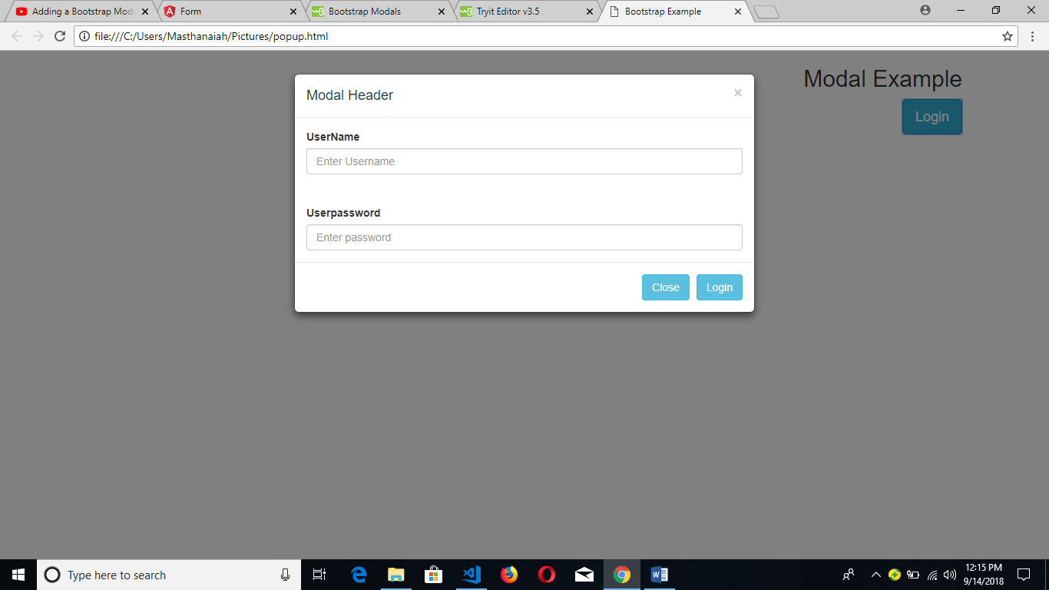

<!DOCTYPE html>

<html lang="en">

<head>

<title>Bootstrap Example</title>

<meta charset="utf-8">

<meta name="viewport" content="width=device-width, initial-scale=1">

<link rel="stylesheet" href="https://maxcdn.bootstrapcdn.com/bootstrap/3.3.7/css/bootstrap.min.css">

<script src="https://ajax.googleapis.com/ajax/libs/jquery/3.3.1/jquery.min.js"></script>

<script src="https://maxcdn.bootstrapcdn.com/bootstrap/3.3.7/js/bootstrap.min.js"></script>

</head>

<body>

<div class="container">

<h2 align="right">Modal Example</h2>

<!-- Trigger the modal with a button -->

<button type="button" class="btn btn-info btn-lg pull-right" data-toggle="modal" data-target="#myModal">Login</button>

<!-- Modal -->

<div class="modal fade" id="myModal" role="dialog">

<div class="modal-dialog">

<!-- Modal content-->

<div class="modal-content">

<div class="modal-header">

<button type="button" class="close" data-dismiss="modal">&times;</button>

<h4 class="modal-title">Modal Header</h4>

</div>

<div class="modal-body">

<label>UserName</label>

<input type="text" class="form-control" placeholder="Enter Username">

<br><br>

<label>Userpassword</label>

<input type="password" class="form-control" placeholder="Enter password">

</div>

<div class="modal-footer">

<button type="button" class="btn btn-info" data-dismiss="modal">Close</button>

<button type="button" class="btn btn-info" data-dismiss="modal">Login</button>

</div>

</div>

</div>

</div>

</div>

</body>

</html>